Practical 08
Name:-Mo Atif Azmi
Batch:-A4_B4_51
Date:-29-10-2025

Aim:-
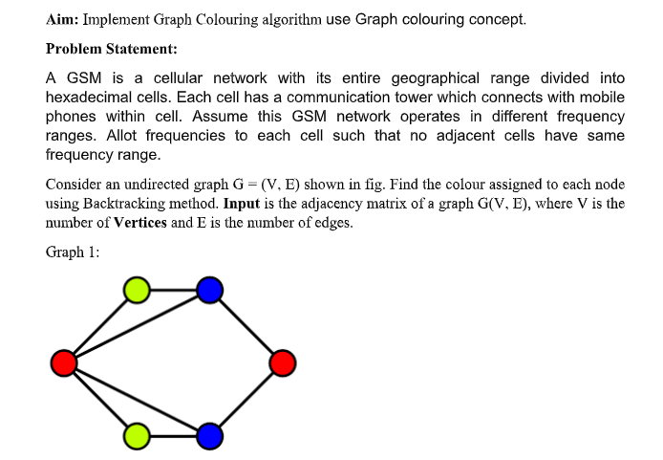
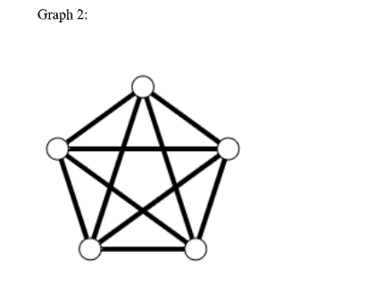

Code:-
def is_safe(graph, colors, v, c):
for i in range(len(graph)):
if graph[v][i] == 1 and colors[i] == c:
return False
return True
def graph_coloring(graph, color_names, colors, v):
if v == len(graph):
print("\nColor assigned to each vertex:")
for i in range(len(colors)):
print(f"Vertex {i + 1} ---> {colors[i]}")
return True
for c in color_names:
if is_safe(graph, colors, v, c):
colors[v] = c
if graph_coloring(graph, color_names, colors, v + 1):
return True
colors[v] = None
return False
graph = [
[0, 1, 1, 1],
[1, 0, 1, 0],
[1, 1, 0, 1],
[1, 0, 1, 0]
]
color_names = ["Red", "Green", "Blue", "Yellow"]
colors = [None] * len(graph)
if not graph_coloring(graph, color_names, colors, 0):
print("No solution exists")

Output:-
